**WEB ANALYTICS REPORT ON MYNTRA**

1. **Brief about Similar Web.**

Similar Web is a web analytics company that offers businesses a comprehensive platform for understanding and analysing online market trends, website traffic, and competitor performance. The platform provides valuable insights into key metrics such as the number of visits, unique visitors, and pageviews, allowing users to gauge the popularity and reach of their websites. Businesses can also leverage Similar Web for competitor analysis, benchmarking their performance against industry averages, and gaining insights into audience demographics and geographic location. The platform extends its analytics capabilities to mobile apps, enabling users to track app performance and user engagement. By offering a range of data-driven insights, Similar Web assists digital marketers, business analysts, and other professionals in making informed decisions to enhance their online presence and competitiveness. It's worth noting that the accuracy of the data may vary, as it relies on sources such as web scraping and partnerships.

1. **Benefits of SimilarWeb.**

* Provides insights into website traffic, including visits, unique visitors, and pageviews.
* Facilitates competitor analysis, offering data on traffic sources, audience demographics, and market share.
* Assists in keyword research for SEO and content optimization.
* Offers audience demographic information for targeted marketing strategies.
* Enables benchmarking against industry averages.
* Extends analytics to mobile apps for performance tracking.
* Supports market research and identification of growth opportunities.
* Helps in strategic planning by refining online presence and optimizing marketing efforts.
* User-friendly interface for easy data access and interpretation.
* Useful for investors and business development professionals in assessing partnerships or investment opportunities.

1. **Parameters that focuses SimilarWeb on.**

* **Users**: In Google Analytics, users are people that visit your website. Google Analytics categorizes users into two categories: new and returning. New users are visitors who have never visited your site, and returning users are visitors who have visited your site before.
* **Sessions**: Google Analytics defines sessions as “a group of user interactions with your website that take place within a given time frame.” Sessions are different from users because one user could trigger numerous sessions. They are helpful to track when examining changes to session count and sessions per source to evaluate how effective your campaigns are
* **Pages per session**: Pages per session are the number of pages a user views during a session. If you see an increase in pages per session, this could mean your users are more engaged with your content because they are navigating to more pages throughout your site.
* **Devices:** The Devices metric in Google Analytics highlights how many users visit your website on desktop, mobile, and tablet devices.
* **Source/medium and channels**: The source metric in Google Analytics refers to where traffic to your website comes from such as from a search engine, such as Google, or direct, where the user goes directly to the URL by typing it out, selects it from a bookmark, or if Google Analytics is not able to identify the traffic origin.
* **Pageviews, unique pageviews**: In Google analytics the pageviews metric refers to the total number of views per page. Pageviews are also counted if a page is viewed by the same user more than once.
* **Time on page**: The average time on page in Google Analytics is the average amount of time a user spends on a single page. By looking at the average time a user spends on a page, you can gauge how engaged the user is with the content. For example, users typically spend more time on blog article pages.
* **Time on Site**: Time spent during the session on the website.

NOTE: Always visits should be greater than the visitors for a particular website

* **Landing pages**: Landing Pages in Google Analytics are the pages through which users enter your website, or the first pages that a user sees when coming to your site. It’s important to analyse your site’s most trafficked landing pages along with
* **Exit pages**: The exit page of a website refers to the last page a user views on a website before they leave the site or before the session ends. By examining what pages your users most exit the site from, you can identify opportunities to optimize these pages to not only keep them on your site, but to boost conversions.

**There are some other imp web metrics we need to focus on:**

* **Visit:** A visit refers to a single instance of a user accessing your website. It is counted each time a user loads a page on your website. For example, if a user lands on your homepage and then clicks on three other pages, that would count as four visits.
* **Visitor:** A visitor refers to an individual user who accesses your website. It is counted once per unique user, regardless of how many times that user visits your website. For example, if the same user visits your website four times, it would count as four visits, but only one visitor.
* **Bounce rate**: A bounce in SimilarWeb is defined as “a single-page session on your site.” If a user goes to your website, does not interact with the site, and then leaves, they do not trigger any additional requests to the Analytics server and are considered a bounce. The bounce rate is the percentage of all sessions on your site that bounced.
* **Conversion rate**: If a website aims to sell knowing how many people will click and continue the sale is important. Conversion rate refers to the people following through with a sale after landing on the website.

NOTE: Conversion rate is making the visitor to buy a product by grabbing the attention of a visitor by creating a sale or a discount offer.

* **Exit Rate:** Exit rate measures the people left from the website from a certain page.
* **Engagement:** It is the no.of repeated visits of a visitor. It also used to measure the degree of engagement and also the kind of engagement.
* **Success Rate:** It is used to measure the effectiveness of a website in achieving its goals. It starts with data from community members, gathered through simple questions.

**ANALYSIS ON MYNTRA**

**Web Analytics User Info about Myntra**

(Total visitors, New visitors, Returning visitors)

Overview:

In website analytics, total users are the unique individuals who visit a site in

a given period. This group is divided into new users, who are visiting for the

first time, and returning users, who have visited before. These metrics,

tracked via cookies or login info, provide valuable insights into audience

behaviour and inform content and marketing strategies. However, their

accuracy can be affected by factors like users clearing cookies or using

different devices.

Benefits:

1. Understand the size and nature of the audience.

2. Track changes in user behaviour over time.

3. Identify trends in user engagement.

Stats:

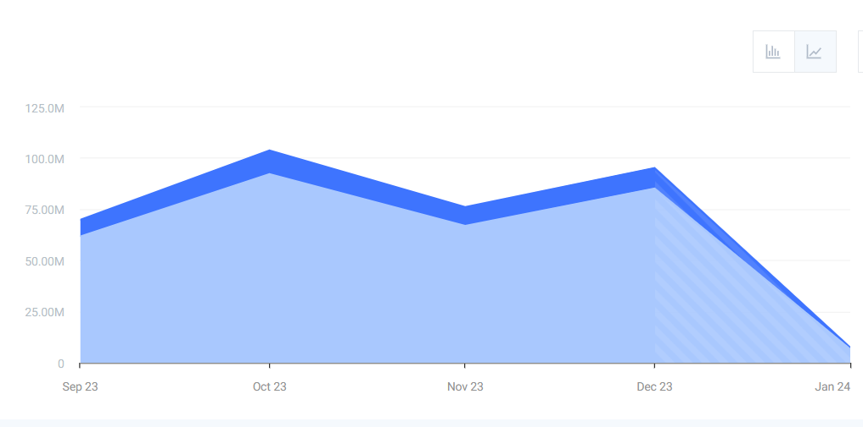

**Present Statistics with Tables and Graphs**

(Page Views, Avg session Duration, Bounce Rate)

Overview:

Page views represent the total number of pages viewed, including repeated

views of a single page. Average session duration is the mean length of a

session, calculated by dividing the total duration of all sessions by the number

of sessions. Bounce rate is the percentage of visitors who leave after viewing

only one page, indicating the relevance of site entrance pages. These metrics,

crucial for assessing user engagement, traffic and website effectiveness,

should be interpreted in context due to influencing factors.

Benefits:

1. Provides a quick snapshot of overall website performance.

2. Helps identify areas of improvement.

3. Enables easy comparison and trend analysis.

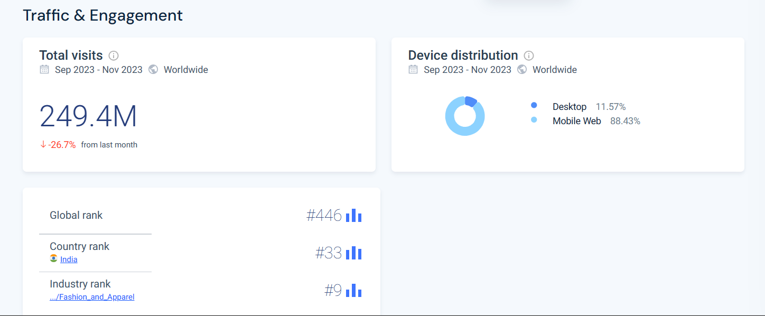

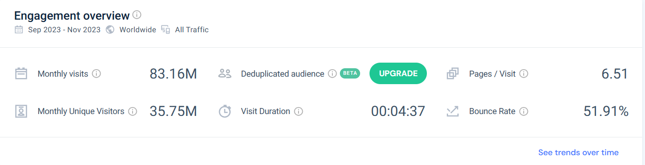

**Interpretation:**

As per above statistics we can say that visitors are spending 4min in avg in this MYNTRA site and the bounce rate is also 51.91% which indicates that MYNTRA is holding up their visitors for long time and also visitors are showing interest to their content.

**• User Acquisition with Charts**

(Organic Search, Paid Search, Social Media, Referrals, Direct)

Overview:

In web analytics, organic search refers to visitors who arrive at a website through

unpaid search results, while paid search involves visitors who come via paid

advertisements. Social media traffic comes from social networks,

and referral traffic is from direct links on other websites. These metrics help

understand the sources of website traffic, informing marketing strategies.

However, they should be interpreted in context due to various influencing factors.

Benefits:

1. Identifies the most effective channels for user acquisition.

2. Informs marketing strategy and budget allocation.

3. Helps optimize campaigns for better ROI

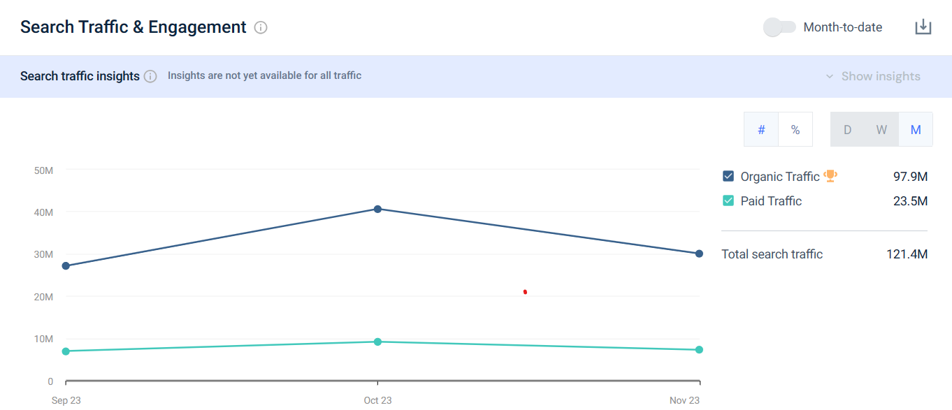

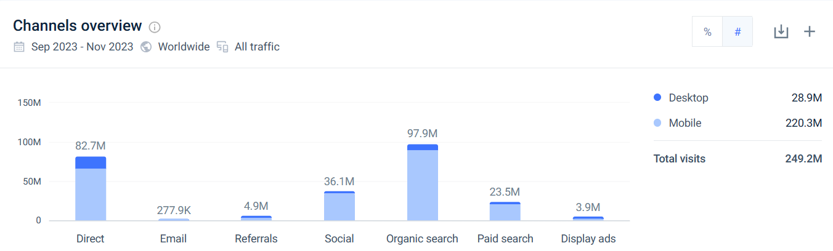

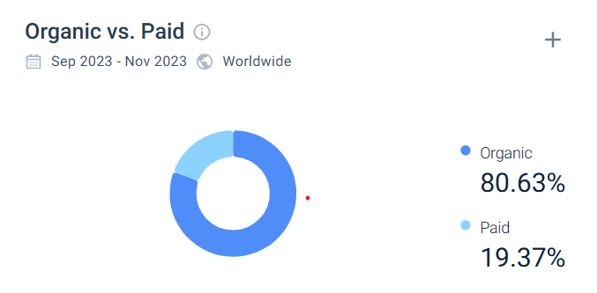

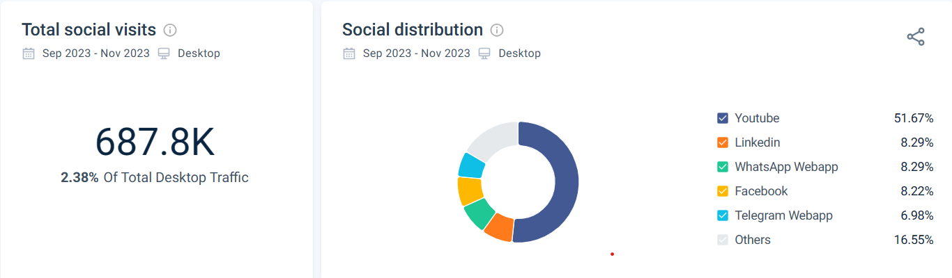

**Interpretation:**

As per the above statistics, the visitors traffic is more from the organic search rather than paid search which indicates that even without the advertising Myntra can perform consistent and also social media traffic has being consistent over 3 months and referrals also contributing some good amount of visitors.

**• Demographic Information(Age Groups & Geographical Locations)**

Overview:

Demographic information in web analytics refers to data about the age, gender,

location, and language of website visitors. This data helps businesses understand their audience better, tailor content, and make informed marketing decisions. However, it’s important to interpret this data in context and respect user privacy.

Benefits:

1. Tailors marketing and content strategies to specific demographics.

2. Guides product/service development based on user characteristics.

3. Informs targeted advertising efforts.

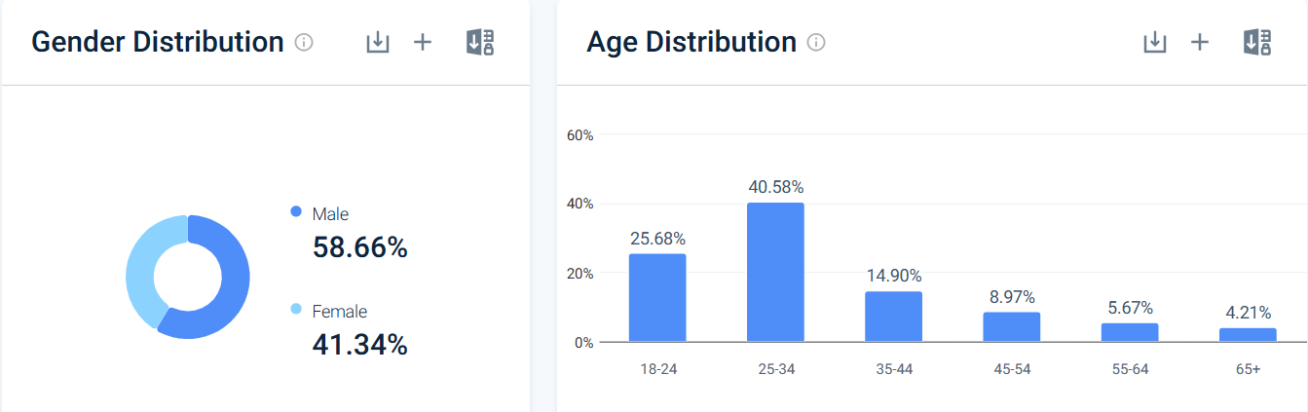

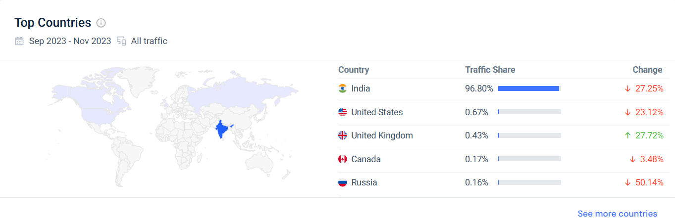

**Interpretation:**

As per the above statistics, we can say that India holds more no. of visitors for Myntra followed by United states, UK and also 25-34 age group people and Males are more attracted and interested in apparels and fashion in myntra.

* **Successful and Failed actions**

(Completed Purchases, Failed Submissions)

Overview:

In web analytics, successful actions like completed purchases or form submissions (e.g., 5,000) indicate effective user engagement. Failed actions such as abandoned carts or failed submissions (e.g., 2,000) highlight areas for improvement. These metrics are crucial for optimizing user experience andconversion rates. However, they should be interpreted in context due to various influencing factors.

Benefits:

1. Pinpoints areas of the website that may need improvement.

2. Guides UX/UI enhancements for a smoother user journey.

3. Informs strategies to increase successful actions.

**Stats:**

Conversion Rate: 2.2%

Site Speed: 2.71sec

Bounce Rate: 51.91%

Performance Score: 46/100

From the above stats, we can decide the successful and failed actions by conversion rate indicates the visitors turned into customers, site speed indicates how fast does a page responds if it takes more time we can consider it as a failed actions, Having a lower bounce rate indicates as a successful action, and also based on the metrics like error pages loaded, event tracking, e commerce tracking we can decide the successful and failed actions of a website.

**MYNTRA Web Analytics Dashboard Report**

Overview:

A Web Analytics Report Chart/Dashboard visually represents website data, including traffic sources, landing page performance, goals & conversions, campaign performance, and social media metrics. This chart aids in understanding website performance and informs optimization decisions. Interpretation should consider various influencing factors.

Benefits:

1. Facilitates easy interpretation and understanding.

2. Supports quick decision-making based on a comprehensive view.

3. Enhances communication by visualizing complex data.

**DASHBOARD:**

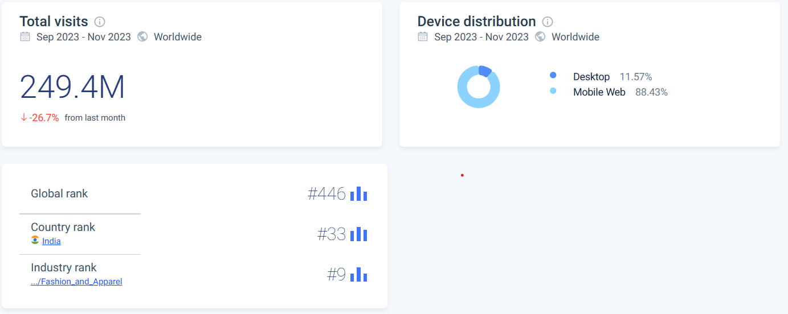

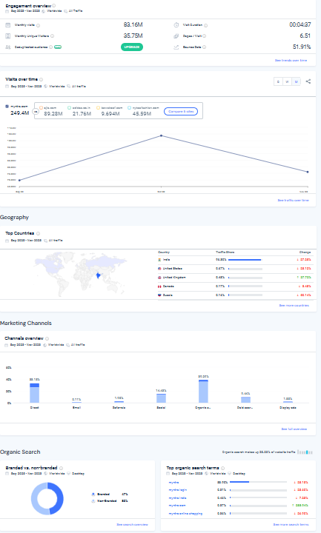

**Comparison of myntra with its competitors**

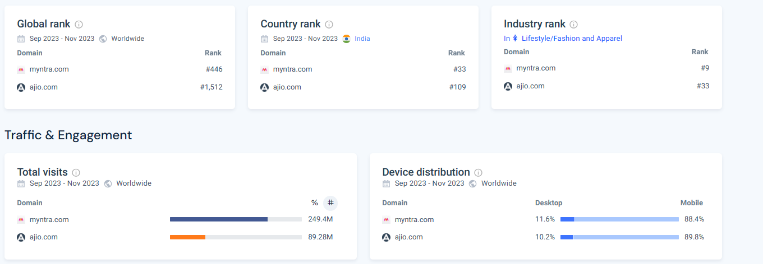

Here we are comparing MYNTRA with its top competitor Ajio. As per the above statistics, we can say that Myntra exceeds Ajio in most of the metrics in monthly unique visitors, visit duration, Page per visit, bounce rate, Page views. Myntra holds top position in the Apparel and fashion.